East Launceston Junior Football Club
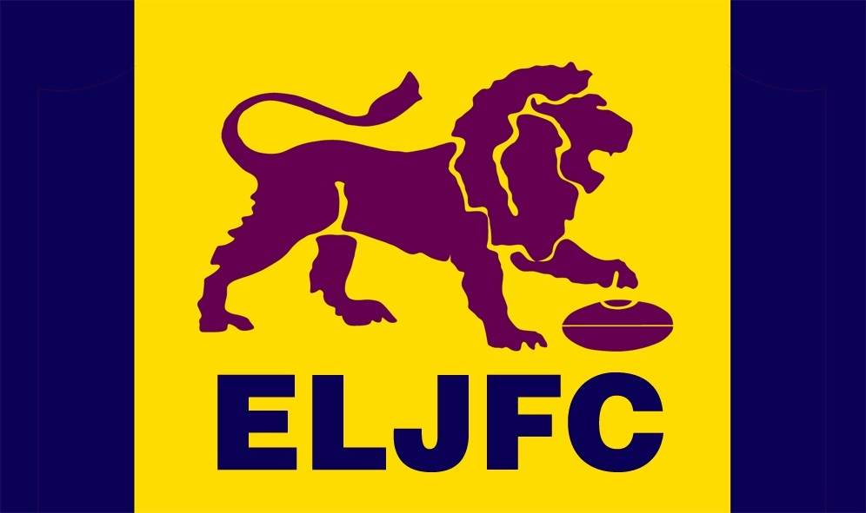

SOCIAL MEDIA POLICY
Policy overview and purpose
Social media is changing the way we communicate.

This policy has been developed to inform our community about using social media so people feel enabled to participate, while being mindful of their responsibilities and obligations. In particular, this policy provides practical guidance allowing all parties to benefit from the use of social media, while minimising potential risks and protecting those involved.

This policy assists to establish a culture of openness, trust and integrity in all online activities related to East Launceston Junior Football Club (ELJFC).

This policy contains ELJFC guidelines for the Club’s community to engage in social media use. It also includes details of breaches of the policy.

In circumstances where guidance about social media issues has not been given in this policy, we suggest the use of common sense or seeking advice from those who have approved this policy.

Underlying principles
This policy complements ELJFC’s core values:

The East Launceston Junior Football Club is a community-oriented club, which seeks to provide a pathway for players from Under 9 through to the Under 17 age groups in the Junior Football Competition under Northern Tasmanian Junior Football Association. Our Focus is on skill building and competition, fitness and health as well as having fun in a safe and enjoyable environment with a sense of belonging, team spirit and sportsmanship.

ELJFC Executive is responsible for all matters related to this policy.

Coverage
This policy applies to all persons who are involved with the activities of ELJFC whether they are in a paid or unpaid/voluntary capacity, including:

- members, including life members of ELJFC.
- persons appointed or elected to ELJFC, committees and sub-committees;
- members of the ELJFC Executive;
- support personnel, including team managers, match managers, sport trainers and others;
- coaches and assistant coaches;
- athletes;
- referees, umpires and other officials;
- member associations
- Parents
- Spectators and other family members

Scope
Social media refers to any online tools or functions that allow people to communicate and/or share content via the Internet.

This social media policy applies to platforms including, but not limited to:
- Social networking sites (e.g. Facebook, Twitter, LinkedIn, Google+, Pinterest, Yammer etc.)
- Video and photo sharing websites or apps (e.g. YouTube, Vimeo, Instagram, Flickr, Vine etc.)
- Blogs and micro-blogging platforms (e.g. Tumblr, Wordpress, Blogger etc.)
- Review sites (e.g. Yelp, Urban Spoon etc.)
- Live broadcasting apps (e.g. Periscope, Meerkat, Facebook Mentions etc.)
- Podcasting (e.g. iTunes, Stitcher, Sound cloud etc.)
- Geo-spatial tagging (e.g. Foursquare etc.)
- Online encyclopaedias (e.g. Wikipedia etc.)
- Instant messaging (e.g. SMS, Skype, Snapchat, WhatsApp, Viber etc.)
- Online multiplayer gaming platforms (e.g. World of Warcraft, Second life, Xbox Live etc.)
- Online voting or polls
- Public and private online forums and discussion boards
- All other online technologies that allow individual users to upload and share content.

This policy is applicable when using social media:

- as an officially designated individual representing ELJFC on social media; and

- if posting content on social media in relation to ELJFC that might affect ELJFC’s services, events, sponsors, members or reputation.

NOTE: This policy does not apply to the personal use of social media where it is not related to or there is no reference to ELJFC or its business, competitions, teams, participants, products, services, events, sponsors, members or reputation. However, any misuse by any individual or group of social media in a manner that does not directly refer to ELJFC may still be regulated by other policies, rules or regulations of ELJFC.

Using social media in an official capacity
You must be authorised by ELJFC before engaging in social media as a representative of ELJFC. To become authorised to represent ELJFC in an official capacity, you must have Current working with Children Registration.

As a part of ELJFC’s community you are an extension of the ELJFC brand. As such, the boundaries between when you are representing yourself and when you are representing ELJFC can often be blurred. This becomes even more of an issue as you increase your profile or position within ELJFC. Therefore it is important that you represent both yourself and ELJFC appropriately online at all times.

Guidelines
You must adhere to the following guidelines when using social media related to ELJFC or its competitions, teams, participants, services, events, sponsors, members or reputation.

Use common sense
Whenever you are unsure as to whether or not the content you wish to share is appropriate, seek advice from others before doing so or refrain from sharing the content to be on the safe side.

When using social media, the lines between public and private, personal and professional, may be blurred. Remember, you are an ambassador for ELJFC.

Protecting your privacy
Be smart about protecting yourself and your privacy.

When posting content online there is potential for that content to become publicly available through a variety of means, even if it was intended to be shared privately. Therefore, you should refrain from posting any content online that you would not be happy for anyone to see, even if you feel confident that a particular individual would never see it.

Where possible, privacy settings on social media platforms should be set to limit access. You should also be cautious about disclosing your personal details.

Honesty
Your honesty—or dishonesty—may be quickly noticed in the social media environment. Do not say anything that is dishonest, untrue or misleading. If you are unsure, check the source and the facts before uploading or posting anything. ELJFC recommends erring on the side of caution – if in doubt, do not post or upload.

Do not post anonymously, using pseudonyms or false screen names. Be transparent and honest. Use your real name, be clear about who you are and identify any affiliations you have.

If you have a vested interest in something you are discussing, point it out. If you make an endorsement or recommendation about something you are affiliated with, or have a close relationship with, you must disclose that affiliation.

The web is not anonymous. You should assume that all information posted online could be traced back to you. You are accountable for your actions both on and offline, including the information you post via your personal social media accounts.

Use of disclaimers
Wherever practical, include a prominent disclaimer stating whom you work for or are affiliated with, for example, a member of ELJFC and that anything you publish is your personal opinion and that you are not speaking officially. This is good practice and is encouraged, but don't count on it to avoid trouble -– it may not have legal effect.

Reasonable use
If you are an employee of or volunteer with ELJFC you must ensure that your personal use of social media does not interfere with your work commitments or productivity.

Respect confidentiality and sensitivity
When using social media, you must maintain the privacy of ELJFCs confidential information. This includes information that is not publically accessible, widely known, or would not expected to be shared outside of ELJFC.

Remember, if you are online, you are on the record—much of the content posted online is public and searchable.

Within the scope of your authorisation by ELJFC, it is perfectly acceptable to talk about ELJFC and have a dialogue with the community but it is not okay to publish confidential information of ELJFC. Confidential information includes things such as details about litigation, or unpublished details of members.

When using social media you should be considerate to others and should not post information when you have been asked not to, or where consent has not been sought and given. You must also remove information about another person if that person asks you to do so.

Permission should always be sought if the use or publication of information is not incidental but directly relates to an individual. This is particularly relevant to publishing any information regarding minors. In such circumstances parental or guardian consent is mandatory.

Gaining permission when publishing a person’s identifiable image
You must obtain express permission from an individual to use a direct, clearly identifiable image of that person.

You should also refrain from posting any information or photos of a sensitive nature. This could include accidents, incidents or controversial behaviour, or any image or information, which may cause embarrassment for discomfort to the person involved.
In every instance, you need to have consent of the owner of copyright in the image.

Complying with applicable laws
Do not post or link to content that contains illegal or indecent content, including defamatory, vilifying or misleading and deceptive content.

Abiding by copyright laws
It is critical that you comply with the laws governing copyright in relation to material owned by others and ELJFC’s own copyrights and brands.

You should never quote or use more than short excerpts of someone else's work, and you should always attribute such work to the original author/source. It is good practice to link to others' work rather than reproduce it.

Discrimination, sexual harassment and bullying
The public in general and ELJFC's employees and members reflect a diverse set of customs, values and points of view. You must not post any material that is offensive, harassing, discriminatory, embarrassing, intimidating, sexually explicit, bullying, hateful, racist, sexist or otherwise inappropriate.

Avoiding controversial issues
Within the scope of your authorisation by ELJFC, if you see misrepresentations made about ELJFC in the media, you may point that out to a Member of the ELJFC Executive. Always do so with respect and with the facts. If you speak about others, make sure what you say is based on fact and does not discredit or belittle that party.

Dealing with mistakes
If ELJFC makes an error while posting on social media, be up front about the mistake and address it quickly. If you choose to modify an earlier post, make it clear that you have done so. If someone accuses ELJFC of posting something improper (such as their copyrighted material or a defamatory comment about them), it is to be addressed promptly and appropriately by both parties, if necessary, legal advice may be sought.

Conscientious behaviour and awareness of the consequences
Keep in mind that what you write is your responsibility, and failure to abide by these guidelines could put your membership at risk.

You should always follow the terms and conditions for any third-party sites in which you participate.

Branding and intellectual property of ELJFC
You must not use any of ELJFC’s intellectual property or imagery on your personal social media without prior approval from a member of the ELJFC Executive.

ELJFC’s intellectual property includes but is not limited to:
- trademarks
- logos
- slogans
- imagery which has been posted on ELJFC official social media sites or website.

You must not create either an official or unofficial ELJFC presence using the organisation’s trademarks or name without prior approval from ELJFC Executive.

You must not imply that you are authorised to speak on behalf of ELJFC unless a member of the ELJFC Executive has given you authorisation to do so.

Where permission has been granted to create or administer an official social media presence for ELJFC, you must adhere to the ELJFC Branding Guidelines.

Policy breaches
Breaches of this policy include but are not limited to:

- Using ELJFC’s name, motto, crest and/or logo in a way that would result in a negative impact for the organisation, clubs and/or its members.
- Posting or sharing any content that is abusive, harassing, threatening, demeaning, defamatory or libellous.
- Posting or sharing any content that includes insulting, obscene, offensive, provocative or hateful language.
- Posting or sharing any content, which if said in person during the playing of the game would result in a breach of the rules of the game.
- Posting or sharing any content in breach of ELJFC’s anti-discrimination, racial discrimination, sexual harassment or other similar policy.
- Posting or sharing any content that is a breach of any state or Commonwealth law.
- Posting or sharing any material to our social media channels that infringes the intellectual property rights of others.
- Posting or sharing material that brings, or risks bringing ELJFC, its affiliates, its sport, its officials, members or sponsors into disrepute. In this context, bringing a person or organisation into disrepute is to lower the reputation of that person or organisation in the eyes of the ordinary members of the public.

Reporting a breach
If you notice inappropriate or unlawful content online relating to ELJFC or any of its members, or content that may otherwise have been published in breach of this policy, you should report the circumstances immediately.

Report it directly to a member of the ELJFC Executive in person or by email. info@eljfc.com.au, president@eljfc.com.au.

Further information about reporting breaches:
- For a complaint about the misuse of social media relating to a match or competition that occurs either prior to, during, or after a game; refer to Northern Tasmanian Junior Football Association Inc.
- For a complaint about the misuse of social media that is general in nature and/or ongoing and does not apply to a particular game; refer to The Office of the eSafety Commissioner https://www.esafety.gov.au/

Investigation
Alleged breaches of this social media policy may be investigated according to ELJFC’s Discipline Committee. Where it is considered necessary, ELJFC may report a breach of this social media policy to police.

Disciplinary process, consequences and appeals
Depending on the circumstances breaches of this policy may be dealt with in accordance with the disciplinary procedure contained in the ELJFC’s constitution.

Employees of ELJFC who breach this policy may face disciplinary action up to and including termination of employment in accordance with ELJFC’s constitution

Appeals
Any person who is sanctioned under a disciplinary process for breach of this policy may have a right of appeal under the ELJFC constitution

Other legal considerations that may be applicable include but are not limited to:
- Defamation
- Intellectual property laws, including copyright and trade mark laws, Privacy, confidentiality and information security laws
- Anti-discrimination laws
- Employment laws
- Advertising standards
- Charter of Human Rights and Responsibilities Act 2006
- Information Privacy Act 2000
- Equal opportunity laws
- Contempt of Court
- Gaming laws

